Chubb, A. “China’s Assertiveness in the South China Sea, 1970-2015,” International Security, Vol. 45, No. 3 (Winter 2020/21).
Appendix
Maritime Assertiveness Time Series Dataset:
PRC in the South China Sea, 1970-2015

This article’s time series of assertive changes in the PRC’s behavior in the South China Sea dispute between 1970 and 2015 is the first dataset in a larger Maritime Assertiveness Time Series (MATS) project. As of March 2020, data collection is complete for Vietnam and the Philippines’ assertive behavior in the South China Sea across the same time period; planned future rounds of data collection will include the PRC and Japan in the East China Sea, and the PRC and India in their terrestrial border dispute.
Preliminary data on assertive changes in the PRC’s behavior in the South China Sea dispute between 1970 and 2015 were compiled from publicly available materials in English- and Chinese-language, as well as some Vietnamese-language sources accessed through Google Translate. However, as noted, a present-centric bias exists in the information supply on such events due to recent increases in attention towards the South China Sea issue, as well as greater publicity from the PRC regarding its own activities. This makes assertive behavior more likely to be observed in recent years. To counteract this, the dataset used here draws extensively upon historical PRC sources. These include internal-circulation PRC chronologies on major events in the South China Sea covering the period up to 1996 (Zhang, NSQDDSJ), advisory reports on the South China Sea from 2002 to 2009 (NISCSS, NHXSPGBG), archived PRC maritime agency web pages (SOA, “Dashiji”), reports on state-run scientific expeditions in the 1980s (CAS, Nansha Qundao), and yearbooks of PRC government maritime agencies covering the 1970s through to present (SOA, ZGHYNJ; Fisheries, ZGYYNJ). Other publicly available materials used included one declassified US military reports and several leaked State Department cables. A full list is appended in the data file.

Stage 1: Master timeline
Data collection took place via a two-stage process. The first was the generation of a master timeline file (not restricted to the post-1970 era) into which was entered any potentially relevant historical developments in the South China Sea dispute, as encountered by the author in the course of researching the issue. The sources for this base of raw information on the dispute included existing academic literature and policy analysis, open-source reports by foreign government departments, archived press reporting accessed through the Factiva database, and news on contemporary events acquired through English and Chinese language media, usually online. The content of the master timeline was not limited to PRC actions and those of its rivals, but included any plausibly relevant information on developments in the dispute: reported actions of third countries, notable statements by officials, bilateral meetings and agreements, important domestic political events, and exogenous international developments. The aim in this process was to cast the net as widely as possible, leaving analysis and verification to the second stage.
The timeline has been continuously added to, filled in, corrected and updated throughout the seven-year duration (as of early 2020) of the project, as more and better information on came to hand. A major step in this process was the systematic study of several important PRC sources mentioned above. Besides identifying numerous otherwise unreported events, this process clarified the timing and nature (and in some cases existence) of already-reported events, while adding valuable inside-out perspective on how the dispute’s progression appeared from within China’s party-state system. The master timeline therefore serves as a reference resource on the context of China’s actions in the South China Sea. It also provides the basis for a more refined set of data with which to identify the timing and nature of the recent changes in the state’s behavior.

Stage 2: Refined time series
The second stage involved refining content from the master timeline by applying the concept of assertiveness outlined in the main text and coding each event that met the definition qualitatively within the four-way typology. The resultant time series captures the variation in China’s assertiveness between 1970 and 2015, relative to 1970. The appropriateness of this reference point is discussed below. Each case constituted an intensification of the PRC’s assertiveness in comparison with the previous year. In total, 132 instances of assertive change, year-on-year, in PRC’s conduct were identified. Per the conceptual framework established in the main text of the article, three criteria determined whether a given action constituted an intensification of assertiveness: qualitative novelty, increased frequency or expanded geographic scope. Using the previous calendar year as reference point served this project’s requirement for fairly precise indications of the timing of policy change. The limitations of this method are discussed separately below.
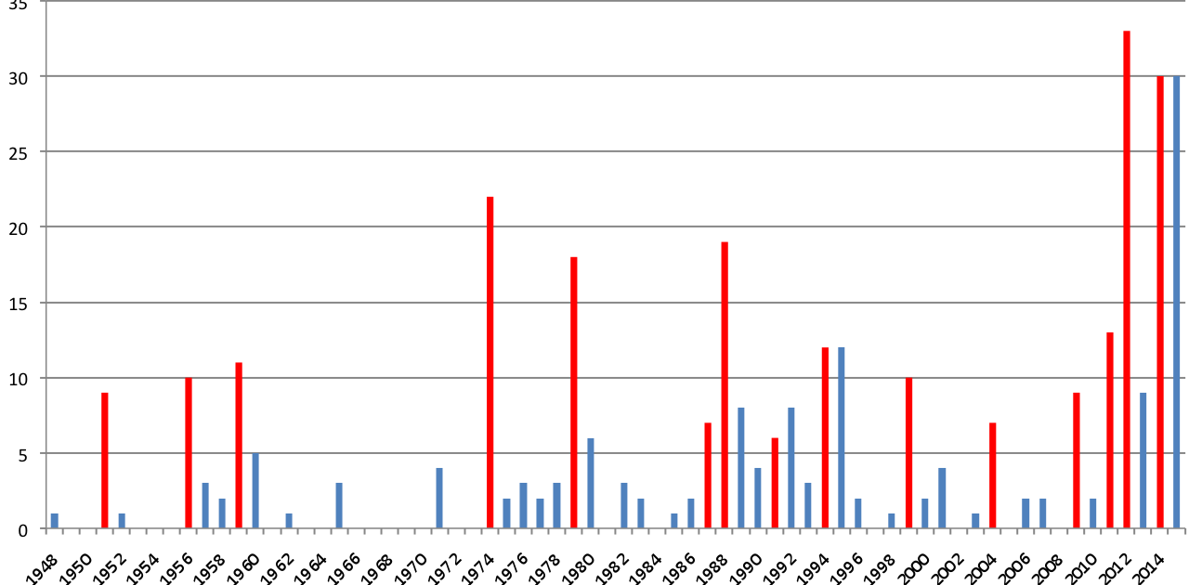
Figure A1: Yearly number of People’s Daily articles mentioning South China Sea islands and sovereignty, 1948-2015. Cases of intensified declarative assertiveness were recorded wherever the number of articles increased by 33% over the previous year, to a minimum of 5 articles. This is indicated by the red bars. From People’s Daily database, search string {沙群岛 主权}.

Most cases of intensified assertive activity were identified from the master timeline, but three other sources of supplementary data also contributed. (1) Search results from of the People’s Daily database, which served as a proxy for the PRC’s level of verbal assertiveness in each year (Figure A1); (2) A chronological list of known PLA Navy exercises in the South China Sea between 2006 and 2015, assembled from the master timeline and searches of Baidu News; and (3) Yearly frequency of civilian maritime patrols in the South China Sea as revealed in a 2013 CCTV documentary (CCTV, “Nanhai Jixing”).

Verification of cases
Although it was not possible to achieve complete certainty regarding the details of every case, each was cross-checked with other sources where available, and considered with specific regard to possible motivations that could bias the source of the information. Several candidate cases from the main timeline were set aside pending possible future confirmation (see data file).
The background to each candidate case of intensified assertive behavior demanded careful consideration. Various aspects of the “status quo” in disputed maritime areas change constantly, such as numbers of ships, patterns of navigation, personnel and equipment. Where a significantly new situation arises, the question of whether a particular state action constitutes an assertive change in behavior hinges on a counterfactual judgment as to how the state would have responded if the same circumstances had arisen in the past. To take a concrete example, PRC on-water enforcement actions against foreign fishing increased in 2007, but this could not automatically be considered a case of intensified assertiveness. The number of Vietnamese fishers operating in the Paracel Islands had increased sharply, and if this had occurred in previous years it is quite likely that PRC enforcement would also have quantitatively increased. The case’s eventual inclusion in the dataset was on the qualitative basis that China’s enforcement methods shifted from the previous practice of harassment and warnings, towards confiscation of property and detention of Vietnamese personnel.
The next step was to consider the likely duration of each action, or pattern of action, in order to identify whether it continued, intensified further or diminished in subsequent years. In most instances, an absence of evidence of equivalent actions in the following year was treated as a diminishment of that particular aspect of China’s assertiveness. There were exceptions, however particularly where long periods separated available data points. One example concerned PRC fishing. Chinese, Vietnamese and Philippine sources reported an increase in PRC fishing activities in disputed parts of the South China Sea in 1994, and the China Fisheries Yearbook records a 26 percent rise in PRC state-sanctioned fishing trips to the Spratly Islands in 2001, but the intensity of China’s fishing activities in the intervening years was unknown. In this case the assumption was made that Chinese fishing had been occurring at approximately the same level across that time period – a more cautious conclusion than to assume either further increases or diminishment. PRC fishing was therefore regarded as having intensified in 1994, and continued over the following seven years, before intensifying again in 2001.

Limitations
These events data are inevitably incomplete, for an assertive state and its adversaries may both have incentives to keep such events secret. To mitigate this risk of unobserved events the author consulted historical sources from different contending sides of the dispute, and concentrated special attention to uncovering events from the period before the dispute became subject to widespread English-language media and scholarly attention, over a period of six years (2011-2017). In recognition of the fact that events in the distant past are both harder to verify and less likely to be found in the first place, stricter evidentiary standards were applied for more recent events. Methodologically, this is appropriate for a study seeking to identify and explain change, for it reduces the probability that changes detected will be spurious or overstated. It should also increase analytic confidence in the existence of any recent changes that are identified.
As with any attempt to distil social processes to numbers, it is crucial to bear in mind the relevant context that may be obscured by these methods. First, these data only include non-cooperative aspects of China’s behaviour. The assertiveness framework does capture moderations of behavior — that is, shifts to fewer, or qualitatively less escalatory, assertive actions over a given time period. But it does not account for actively conciliatory actions such as agreements over resource exploitation or management, joint patrols and other confidence-building measures (CBMs). While it would be desirable to capture all aspects of a state’s dispute behavior in one dataset, the exclusion of cooperative actions was necessary because actively conciliatory measures do not necessarily offset or mitigate assertive actions. This decision also reflects the project’s purpose of identifying the timing and nature of the recent change in state behaviour in the South China Sea in order to better understand its causes. Future work may develop appropriate ways to simultaneously account for both non-cooperative and cooperative dispute behaviour.
Second, the events data are limited to those actions that are observable and documented in the sources consulted. The strategy employed to counteract this consisted of (1) casting the data-gathering net as widely as possible, including both English-and Chinese-language sources, and (2) including all possibly relevant developments, both confirmed and unconfirmed, in the master timeline from which the events data were drawn, thus allowing time for evidence to emerge that could confirm or refute candidate cases. Another related limitation inherent in relying on events data is that there may be a lag between important political decisions that set in motion a policy change, and the observable manifestations of this. Thus, positivist approach that underpin these data need to be complemented by close analysis of speech and text, in order to account for how the actors involved understood their actions, as well as to identify more remote but nonetheless fundamental causes of policy change.
Third, being focused on China’s assertiveness, these data do not account for other states’ assertive actions. Instead, these are discussed separately in the process of explaining the observed changes in PRC behavior. External developments, for example, relate closely to the “declining claim strength” explanation. As noted above, external developments were included in the master timeline, but not the 132 cases of PRC policy change that constitute the time series analyzed here. Although beyond the scope of this article’s analysis, the MATS project has so far gathered data matching time series on the assertive actions of the Philippines and Vietnam. Analysis of these and other matched time series capturing behavioral changes of other claimants and powers that operate in the area, such as the U.S., Australia, Japan and India, could offer new insight into the action-reaction dynamics of the Asia-Pacific’s disputed maritime spaces. Further planned expansion of the MATS project will encompass include territorial disputes, starting with the PRC-India border dispute.

Unit of analysis
Measuring behavioral change by comparing state actions in one calendar year with the one that preceded it was a pragmatic decision. Other units of comparison could generate different findings about when, or even whether, change has occurred. The specific actions taken in the Impeccable incident, for example, were probably unprecedented, but the incident can also be understood as a continuation of the policy that produced the EP-3 incident in a similar area in 2001. Similarly, the unilateral resource survey activities China carried out in 2014 are not known to have occurred in 2013, but similar activities were observed in similar geographical areas in 2010 and 2007. Although this could be characterized this as a single case of change (no explorations before 2007, explorations every 3-4 years afterwards), under the year-on-year method this constitutes three separate cases of intensification of assertive activity, followed by its diminishment the following year. Besides allowing for the identification of the timing of behavioural change down to a one-year range, using calendar years also seems a less arbitrary choice than wider units of time.
The quantitative assertiveness framework implicitly gives equal weight to actions of varying significance. For example, the method of handling Vietnamese fishers in the Paracels became more coercive in 2009 and 2011 with the increased detentions of personnel and seizure of boats, but its intensity remained far below that seen in the January 2005 Sino-Vietnamese fisheries incident in the Gulf of Tonkin, in which nine Vietnamese personnel were killed, or the fatal 2007 incident in the Paracels. South China Sea sovereignty declarations in the party’s official press increased substantially 2009 and 2011, but the party media had been equally vociferous in 1999 and 2004, and much more vocal in 1988 and 1995. The massive land reclamation works since late 2013 are also not weighted for their significance, except insofar as they enable further assertive actions in the future. The typology used here represents a compromise between the need for a more systematic measurement of change, and the need to account for the significance of different kinds of actions.

Baseline 1970
The year 1970 is a logical starting point because it follows closely after preliminary surveys suggested the possible presence of major resource deposits in the area. This “discovery” created one of the key factors in the high-stakes dispute that exists today. Although several states, including the PRC, announced claims in the area in the 1940s and 1950s, the UN Economic Commission for Asia and the Far East’s survey indicating potentially massive oil and gas bounties sharply increased the incentives for claimants on all sides to pursue those claims. The list below shows a selection of known instances of PRC actions over the South China Sea between 1949 and 1969 that provides the zero-baseline for comparing the PRC’s assertiveness between 1970 and 2015.
Selected assertive PRC actions in South China Sea in 1949-1969
1949, November: First PRC map published incorporating ROC eleven-dash line (“Xin Zhongghuo diyizhang ditu,”)
1950, May 20: PRC publicly asserts sovereignty over Spratlys in RMRB p.1 articles condemning Philippines’ claims (Chen, “China’s ASEAN policy,” p. 149).
1950-1956: Qionghai fishers operate in Spratlys (Zhang, NSQDDSJ, 3). But according to another source the PRC prohibited its citizens from fishing in Spratlys form 1954 onwards (Guo Jinfu, “Nansha yuye ziyuan,” p. 298).
1950-1956: Guangdong Hainan Administrative Region allegedly erects weather stations, conducts surveys, extracts phosophorous and “manages fishing” in Paracels. (Zhang, NSQDDSJ, p. 3).
1951, August: Zhou Enlai publicly asserts sovereignty over four South China Sea “island groups” (Samuels, Contest, pp. 78-9).
1956: PRC occupies Amphritrite Group in north-eastern Paracels.
1956-1959: PRC mines more than 100,000 tons of phosphates in Paracels. By 1961 the supply was exhausted (Lei, NSZGSZH, p. 133).
1958: PRC Territorial Sea Declaration asserts territorial sovereignty and seas around the four South China Sea “island groups,” but not Diaoyu Islands.
1959: Office for Zhongsha, Xisha and Nansha Affairs established.
1959: first PLAN patrol of Paracels (Fravel, Strong Borders, p. 275n25).
1960: construction of radio masts & observation tower at Woody Island. (Fravel, Strong Borders, p. 275).
1960: PLAN conducts sixteen patrols to protect Chinese fishers in the Paracels. (Fravel, Strong Borders, p. 275).
1960-1973: Average of 5 PLAN patrols per year in the Paraces (Fravel, Strong Borders, p. 275).
1958-1971: China issues 497 protests and warnings over US surveillance above the Paracels (Fravel, Strong Borders, p. 275n32).

Figures A2 to A4 below reproduce Figure 2 from the main article at a higher scale, illustrating the PRC’s overall level of assertiveness in each year, relative to the 1970 baseline. Case numbers corresponding to those used in the events data set are added.

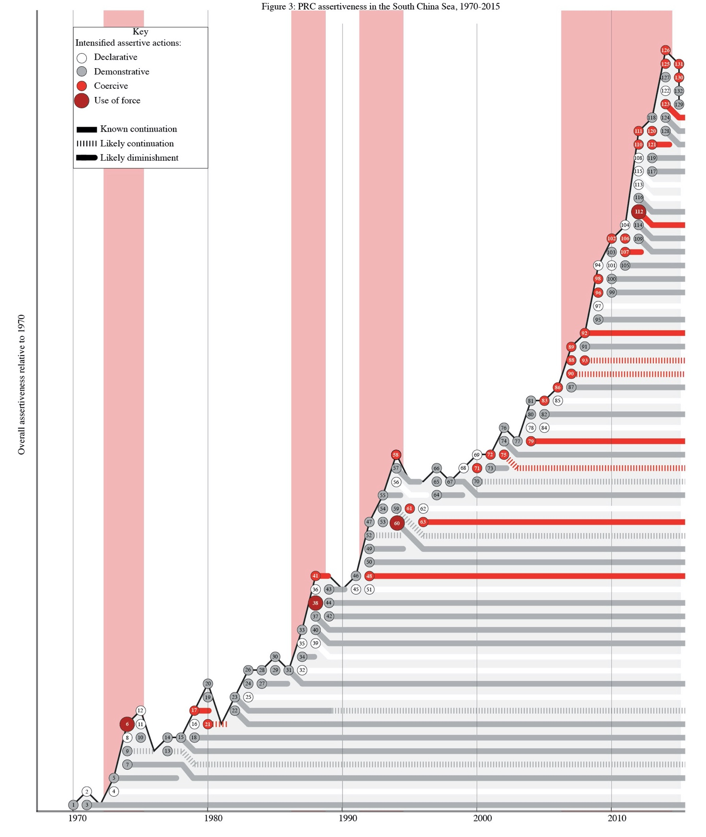
Figure A2: Accumulation of PRC assertive behaviors in South China Sea, 1970-2015. Four periods of rapidly intensifying assertiveness are highlighted.

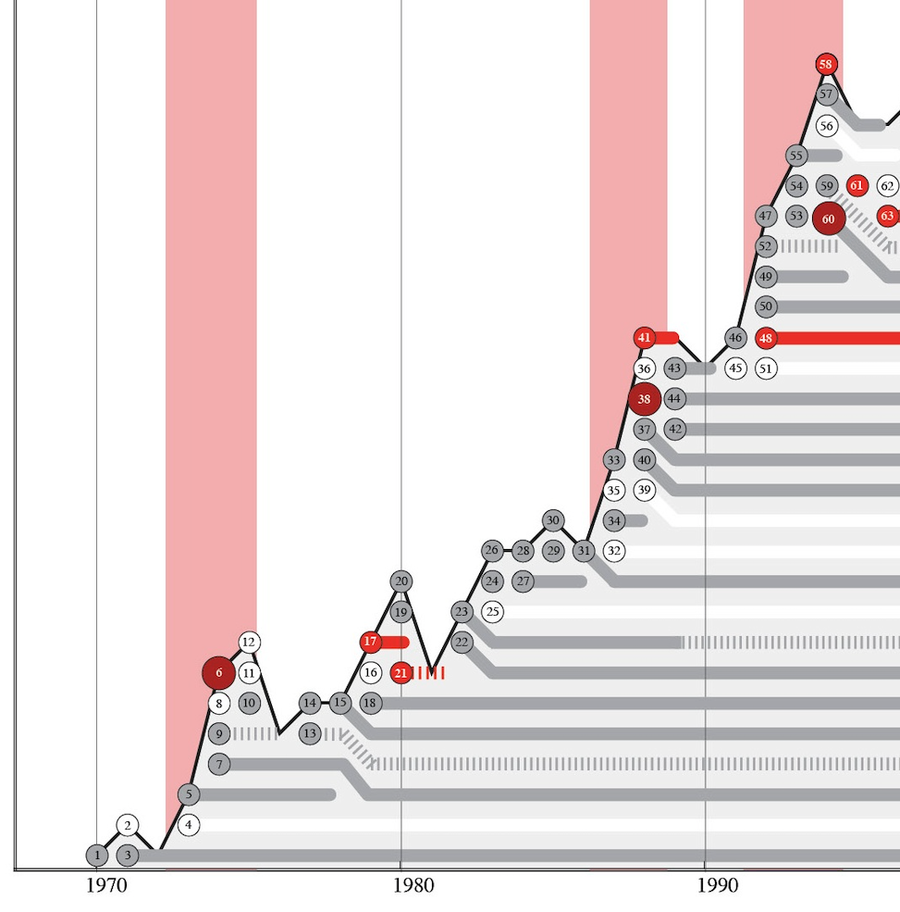
Figure A3: Accumulation of PRC assertive behaviors in South China Sea, 1970-1995, with case labels. See data file for individual case details.

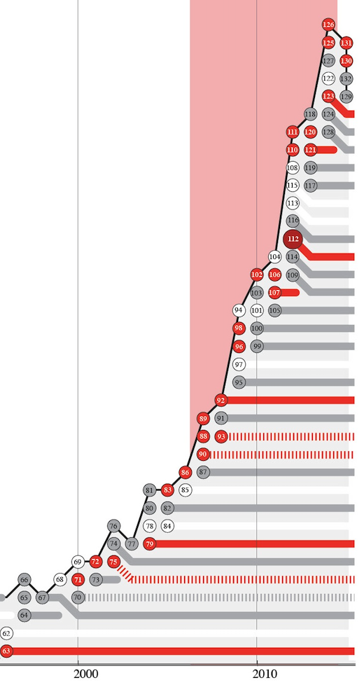
Figure A4: Accumulation of PRC assertive behaviors in South China Sea, 1996-2015, with case labels. See data file for individual case details.
Descriptive statistics
The PRC’s assertiveness in the South China Sea intensified in some form in 8 out of the 10 years in the 1970s, 9 out of 10 years in the 1980s, 9 out of 10 years in the 1990s, and every year between 2000 and 2015. Most intensifications of PRC assertive activity continued in subsequent years, establishing new baselines. Of the 132 cases in the events dataset, 50 (37.8%) are likely to have continued through 2015, and a further 23 (17.4%) continued at least into the following year. Only 55 (41.7%) were one-off incidents or temporary surges in activity that lasted less than a year.
 | Once-off or diminished in next year | Continued but diminished by 2015 | Ongoing through 2015 | 2015 cases | Total
No. of cases (% total) | 55 (41.7%) | 23 (17.4%) | 50 (37.8%) | 4 (3.0%) | 132
Table A1: Estimated duration of cases of intensified PRC assertiveness, 1970-2015.

Overall, the 132 cases of intensified assertive behavior identified between 1970 and 2015 equate to an average of 2.9 per year. Outside the four periods of rapid intensification of assertive activity, the average number of intensified assertive behaviors observed in each year was 1.8. This can be regarded as illustrative of the baseline rate of growth of PRC assertiveness.
Period | Cases of intensified PRC assertiveness | Number of years | Mean cases per year
(1970-1972) | 3 | 3 | 1.0
1973-1975 | 9 | 3 | 3.0
(1976-1986) | 19 | 11 | 1.7
1987-1988 | 10 | 2 | 5.0
(1989-1991) | 5 | 3 | 1.7
1992-1994 | 14 | 3 | 4.7
(1995-2006) | 26 | 12 | 2.2
2007-2015 | 46 | 9 | 5.1
Total | 132 | 46 | 2.9
Table A2: Periods of intensifying PRC assertiveness (bold) in South China Sea.

Focusing on new coercive actions, only 13 cases of intensified PRC coercive behaviors were identified between 1970 and 2006 – an average of 0.3 cases per year. In contrast, 19 such cases are observed in the nine years from 2007 to 2015, an average of 2.1 per year. Table A3 reports the results of an independent samples t-test confirming the statistical significance of this change. It also indicates that, if coercive forms of assertive activity are excluded, the difference between the PRC’s level of assertiveness pre- and post-2007 periods no longer meets conventional levels of statistical significance.
Types of assertiveness | Period | Number of cases | Mean cases per year | t | Sig. (2-tail)
Declarative | 1970-2006 | 20 | 0.5 | 0.95 | 0.37
Declarative | 2007-2015 | 8 | 0.9 | 0.95 | 0.37
Demonstrative | 1970-2006 | 50 | 1.4 | 1.74 | 0.11
Demonstrative | 2007-2015 | 17 | 2.0 | 1.74 | 0.11
Coercive | 1970-2006 | 13 | 0.4 | 8.17 | 0.00
Coercive | 2007-2015 | 20 | 2.1 | 8.17 | 0.00
Force | 1970-2006 | 3 | 0.1 | 0.25 | 0.81
Force | 2007-2015 | 1 | 0.1 | 0.25 | 0.81
Total | 1970-2006 | 86 | 2.3 | 4.22 | 0.00
Total | 2007-2015 | 46 | 5.1 | 4.22 | 0.00
Total excl. coercive | 1970-2006 | 70 | 1.9 | 1.74 | 0.11
Total excl. coercive | 2007-2015 | 26 | 2.9 | 1.74 | 0.11
Table A3: Independent samples t-test for equality of mean annual number of PRC intensified assertive actions in South China Sea, pre- and post-2007 periods (equal variances not assumed).

Dyadic and issue analysis
To identify variation in the targets and immediate purposes of the PRC’s assertiveness, each intensified assertive action was coded according to which bilateral relationships was implicated, and which of the key issues of security, administrative control, resources and politics the action addressed.
In 64 cases (48%) a single dyad was identifiable, usually due to one particular state’s assets being targeted, or because the events in question concerned the Paracel Islands and Scarborough Shoal, which are bilateral PRC-Vietnam (coded V) and PRC-Philippines disputes (coded P) respectively. Other activities concerned disputes over surveillance activities and interpretations of international law between the PRC and the US (coded U). Some 21 assertive actions (16%) have implications for states at large — such as introduction of civil airspace regulations, or military exercises taking place in unspecified waters within the sea. Such cases were coded (A).
Events concerning the Spratly Islands present the most complexity in identifying the bilateral relationships impacted by assertive actions. Where an action took place in, or was targeted at, an identifiable geographical area, this was considered to involve the dyads formed between the PRC and other claimants to that area. For example, activities to strengthen administration of the “central South China Sea” area referred to in many PRC sources, concern areas between the Paracel and Spratly Islands that touch upon the EEZ and continental shelf claims of the Philippines as well as Vietnam. Such cases were thus coded as both (P) and (V). The PRC’s outposts in the Spratly Islands are disputed by Vietnam and the Philippines only, so actions taking place there were likewise coded as (P) and (V), except where they had clear strategic implications for other states, such as the large-scale island-building campaign in that area from 2013 onwards. Where an action concerned PRC claims to the Spratly Islands as a whole, as the PRC’s verbal assertions typically do, this would implicate three bilateral relationships: PRC-Malaysia (M), PRC-Philippines (P), and PRC-Vietnam (V). Finally, where the PRC’s actions concerned the entire nine-dash line area, such as surveys or patrols of the area, this also implied, in the case of energy developments, PRC-Brunei relations (B) and, in the case of fisheries, PRC-Indonesia relations (I).
Not surprisingly, given the larger scope of dispute between the two countries the Sino-Vietnamese relationship was the most often impacted by the PRC’s assertive conduct, with 71% of the cases involving PRC-Vietnam disputes. China-Philippine disputes were the next most commonly featured, with 52% of cases. PRC actions implicating its relations with Malaysia comprised 36%, with Brunei 15%, and Indonesia 11%. Only 8% of assertive behavioral changes — 11 of the 132 cases — had specific implications for Sino-US relations, while twenty-three cases, or 17%, had implications for states in general.
Over time, as Table A4 shows, the PRC’s assertive advances have tended to impinge on the interests of a broadening array of states. The PRC’s surges in the 1970s, 1980s and 1990s were predominantly at the expense of Vietnam and the Philippines, and to a lesser extent Malaysia and Brunei. However, the post-2007 period has seen an increase in assertive actions affecting the claims and interests of Indonesia, the United States, and states in general (A).
 | To-tal | Vietnam (V) | Philip-pines (P) | Malaysia (M) | Brunei (B) | Indonesia (I) | U.S. (U) | All states (A)
1973-1975 | 9 | 8 (89%) | 5 (56%) | 3 (33%) | - | - | 1 (11%) | 1 (11%)
1987-1988 | 10 | 9 (90%) | 7 (70%) | 6 (60%) | 2 (20%) | 1 (10%) | - | -
1992-1994 | 14 | 12 (86%) | 9 (64%) | 6 (43%) | 3 (21%) | 1 (7%) | 1 (7%) | 1 (7%)
2007-2015 | 46 | 25 (54%) | 21 (46%) | 15 (33%) | 8 (17%) | 9 (20%) | 5 (11%) | 9 (20%)

Table A4: Dyadic composition of case counts during assertive surge periods

Overall, 39 out of the 132 cases of assertive change in the PRC’s behavior directly concerned the military and security aspects of the dispute, such as territorial control and military activities (30%). The majority of the cases, 74 (56%), were actions that directly advanced the PRC’s administrative control, such as surveying, patrolling and infrastructure construction. The PRC’s claims to the area’s energy resources were advanced in 26 cases (20%), while 23 cases (17%) concerned fisheries. One quarter of the PRC‘s new assertive actions were direct political statements and lobbying attempts.
As Table A5 shows, the PRC’s surges in the South China Sea have become increasingly civilianized, with proportionally less of the relevant events concerning military and security interests over time, and correspondingly more related to administrative control. This is to be expected as the PRC has fought its way into the Spratly area, and then normalized its presence from an initially tenuous position. Interestingly, resource issues were at the center of events only in the surge beginning in 1992.
 | Total | Military/ security | Administrative control | Energy resources | Fisheries | Political
1973-1975 | 9 | 4 (44%) | 4 (44%) | 1 (11%) | 1 (11%) | 5 (56%)
1987-1988 | 10 | 5 (50%) | 3 (30%) | 1 (10%) | 1 (10%) | 3 (30%)
1992-1994 | 14 | 3 (21%) | 7 (50%) | 5 (36%) | 3 (21%) | 4 (29%)
2007-2015 | 46 | 8 (17%) | 31 (67%) | 6 (13%) | 7 (15%) | 12 (26%)

Table A5: Issue composition of case counts during assertive surge periods

Coding checks
The four types of assertive action that comprise the typology outlined in the main text were designed to be clearly defined and mutually exclusive. Despite these efforts, some ambiguities inevitably remain. To check the analytic validity of the typology and the author’s coding (C0), two students were employed to independently re-code the 132 cases on the basis of the case narratives and the typology as described in the article. One brought a background knowledge of the South China Sea dispute (C1), while the other had previously studied architecture and had recently commenced a Master’s degree in international affairs (C2). One was an American citizen, the other a PRC citizen, and both were enrolled at US universities. C1’s coding matched the author’s for 122 out of 132 cases (92.4%), while C2’s was identical for 115 cases (87.1%). Both C1 and C2’s codings produce even larger differences in the mean number of coercive cases before and after 2007. This should increase confidence that the qualitative behavioral change identified in 2007 is the result of a qualitative shift in the PRC’s conduct, rather than biases of the author.

Author (C0) | Declarative | Demonstrative | Coercive | Use of force
Total 1970-2006 | 20 | 50 | 13 | 3
 | 0.54 | 1.35 | 0.35 | 0.08
Total 2007-2015 | 8 | 18 | 19 | 1
 | 0.89 | 2.00 | 2.11 | 0.11
Totals | 28 | 68 | 32 | 4

Coder 1 (C1) | Declarative | Demonstrative | Coercive | Use of force
Total 1970-2006 | 17 | 51 | 15 | 3
 | 0.46 | 1.38 | 0.41 | 0.08
Total 2007-2015 | 6 | 17 | 22 | 1
 | 0.67 | 1.89 | 2.44 | 0.11
Totals | 23 | 68 | 37 | 4

Coder 2 (C2) | Declarative | Demonstrative | Coercive | Use of force
Total 1970-2006 | 16 | 51 | 12 | 7
 | 0.43 | 1.38 | 0.32 | 0.19
Total 2007-2015 | 7 | 17 | 21 | 1
 | 0.78 | 1.89 | 2.33 | 0.11
Totals | 23 | 68 | 33 | 8

Tables A5-A7: Pre-2006 and post-2007 coding results for three coders

 | Declarative |  |  | Demonstrative |  |  | Coercive |  |  | Use of force
 | C0 | C1 | C2 | C0 | C1 | C2 | C0 | C1 | C2 | C0 | C1 | C2
Total 1970-2006 | 20 | 17 | 16 | 50 | 51 | 51 | 13 | 15 | 12 | 3 | 3 | 7
Mean | 0.54 | 0.46 | 0.43 | 1.35 | 1.38 | 1.38 | 0.35 | 0.41 | 0.32 | 0.08 | 0.08 | 0.19
Total 2007-2015 | 8 | 6 | 7 | 18 | 17 | 17 | 19 | 22 | 21 | 1 | 1 | 1
Mean | 0.89 | 0.67 | 0.78 | 2.00 | 1.89 | 1.89 | 2.11 | 2.44 | 2.33 | 0.11 | 0.11 | 0.11
Totals | 28 | 23 | 23 | 68 | 68 | 68 | 32 | 37 | 33 | 4 | 4 | 8

Table A8: Summary results of coding checks

Johnston, “How New and How Assertive,” pp. 27-28. Johnston cites the PRC’s actions in the 2010 Diaoyu Islands incident as a plausible but indeterminate example of a more-assertive policy, based on a counterfactual scenario analogous to the 2010 situation occurring in an earlier period. Johnston considers it possible that China would have responded similarly in the past if Japan had used domestic legal processes to try a Chinese national detained in the disputed islands’ territorial waters.
Given the importance of worst-case planning in state security policies, the perception of security threats resulting from increased assertiveness may outweigh the material benefits of any simultaneous conciliatory actions. If so, it is not appropriate to implicitly equate the two by offsetting assertiveness against conciliatory actions in the same dataset. This is not to dismiss the significance of conciliatory measures, but it does suggest they should be considered separately. Assertiveness in maritime territorial disputes could be mitigated by conciliatory and cooperative actions if they credibly suggest some limitation on assertive actions in the future. Resource-sharing arrangements, such as joint development of energy resources and cooperative fisheries management, may help to ease rivals’ concerns about missing out on disputed resources altogether. Joint patrols allow two countries to simultaneously manifest administrative presence in a disputed area without undermining each other’s claims, as does cooperation over non-traditional security challenges affecting the area. CBMs and crisis management mechanisms such as hotlines and on-water protocols, if implemented effectively, can increase the security of all states’ positions by rendering their rivals’ actions more predictable, thereby decreasing the likelihood that an unplanned encounter will result in a sudden severe negative shift in their relative bargaining position. And multilateral documents pledging policy restraint, such as the 2003 ASEAN-China DOC, can also mitigate assertiveness to the extent that they generate belief in the likelihood of future assertive actions diminishing or at least not intensifying. However, establishing how, and indeed if, the two should to be balanced against each other, will require significant further investigation.
Yung and McNulty’s database of actions, if eventually released publicly, could offer a starting point for such a project, as it includes actions by all South China Sea claimants actions since 1995. See Yung and McNulty, “China’s Tailored Coercion”; and Yung and McNulty, “Empirical Analysis.”
Samuels, Contest, 155, 164-165n4.

